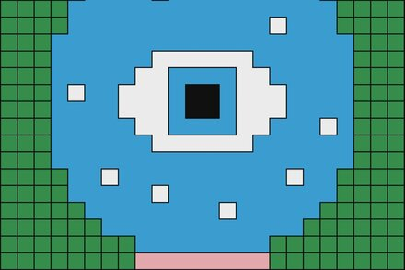

Content:
The Image depicts a pixelated, geometric design resembling an eye. It features a central black square surrounded by concentric shapes, a white layer, a larger blue area with smaller white squares scattered within it, and green blocks framing the outer edges. A thin pink line runs along the bottom edge.
Form:
The image is composed of grid-like squares, giving it a digital or pixel-art aesthetic. The composition is symmetrical and centered, emphasizing the focal point, the black square, which serves as the “pupil.” The blue dominates the visual field, evoking a sense of calm or openness, while the green and pink offer contrast and grounding. The use of white squares dispersed throughout the blue adds rhythm and a sense of depth or sparkle, breaking up the solid color field. The flat, saturated colors and rigid geometry create a sense of order and simplicity.
Meaning:
Visually, the image resembles a stylized eye, suggesting themes of vision, observation, or awareness. The black center could represent focus or the unknown, while the surrounding layers symbolize layers of perception or protection. The pixelated style evokes the digital world, perhaps commenting on technology, artificial intelligence, or how we “see” and process information in the digital age.
Elements of conceptualization
The image incorporates metaphor and scale as conceptual techniques. The “eye” can serve as a metaphor for surveillance, consciousness, or the act of seeing itself, both human and artificial. The use of pixelation plays with scale, reducing complex imagery to simplified blocks, reflecting how digital systems process vast data as bits and pixels. There’s also a sense of reversal, something organic (an eye) is rendered in an artificial, mechanical style, inverting expectation. The paradox lies in how this minimal, abstract composition can still evoke something deeply human and recognizable.
Personal Reflection
This image strikes me with the similarity to the 1984 book cover by George Orwell. 1984 is about a futuristic world where everyone is being watched and controlled by “Big Brother.” The cover of the book is red with a big eye watching over a city. This pixelated eye and Orwell’s eyes are very similar, and I wonder if the pixelated eye was based on Orwell’s. The article is about how A.I. is changing our world. I wonder if deeper research into the writer’s comparison of A.I. to a figure like “Big Brother”, where it is slowly making its way into our lives, could eventually control them. The image reminds me that technology can both connect and monitor us, depending on how it’s used. I’m drawn to the balance between the clean geometry and the underlying message about perception and data; it makes me reflect on how much of our “vision” today is mediated through screens.

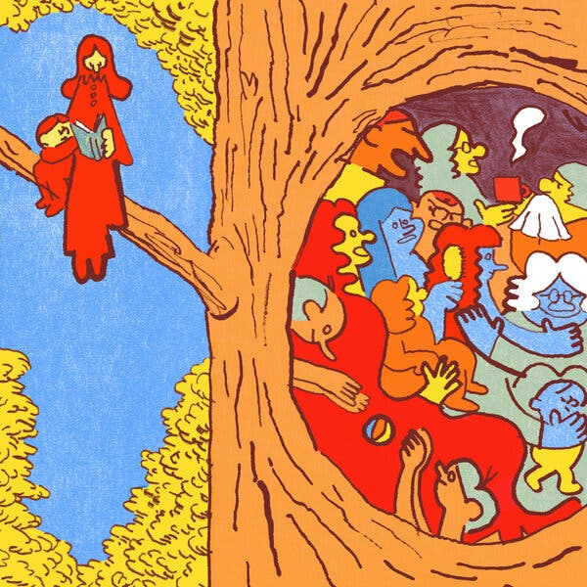
Content:
The image depicts a large tree with a hollow filled with numerous abstract, cartoon-like figures engaged in various activities. The hollow contains people in different postures, some holding objects like a cup or a ball, and interacting with each other. Outside the hollow, two red figures stand on a branch, one reading a book while the other leans on them, seemingly observing or resting. The figures are simplified, with bold outlines and exaggerated features.
Form:
The tree trunk vertically divides the image, creating a contrast between the dense, crowded hollow and the open, airy space outside. The eye naturally moves from the busy interior to the calmer exterior figures. Bright, flat colors dominate the image: reds, blues, yellows, and oranges. The colors contrast sharply, highlighting individual figures and their interaction. Minimal texture is used; the image relies on solid blocks of color and line work to create form. The tree’s bark is outlined simply, emphasizing structure over realism. The lighting is abstract and non-naturalistic. Color contrast rather than shading defines depth, giving the image a playful and graphic quality.
Meaning:
The image conveys a sense of community, activity, and human interaction within the tree hollow, suggesting warmth, closeness, or even chaos. The external figures, apart from the hollow, evoke calm, observation, and contemplation, emphasizing a contrast between social engagement and solitude. There is an underlying feeling of inclusivity and interconnectedness, but also the tension of crowding versus space.
Elements of conceptualization:
The figures inside the hollow are exaggeratedly crowded, emphasizing intimacy and complexity, while the two outside figures are isolated and enlarged in comparison, highlighting separation. The tree can be read as a metaphor for life, shelter, or human society, a single structure holding multiple experiences. There is a paradox between the bustling, chaotic interior and the serene, open exterior, reflecting tension between community and solitude. Typically, a hollow in a tree is seen as empty or natural, but here it is filled with lively human activity, reversing expectations. The hollow can symbolize broader human society, where each figure represents different roles, actions, or relationships within a collective environment.
Personal reflection:
This image resonates with me as a vivid representation of social life and human experience. The crowded hollow evokes feelings of warmth and energy but also a sense of overwhelm, reminding me of how communal spaces can be both comforting and chaotic. The contrast with the two figures outside prompts reflection on solitude and observation; sometimes stepping back offers clarity. I also appreciate the playful, almost storybook style, which softens complex themes and allows for multiple interpretations. It makes me think about how life balances moments of connection with moments of introspection, all under the same overarching “tree” of existence.

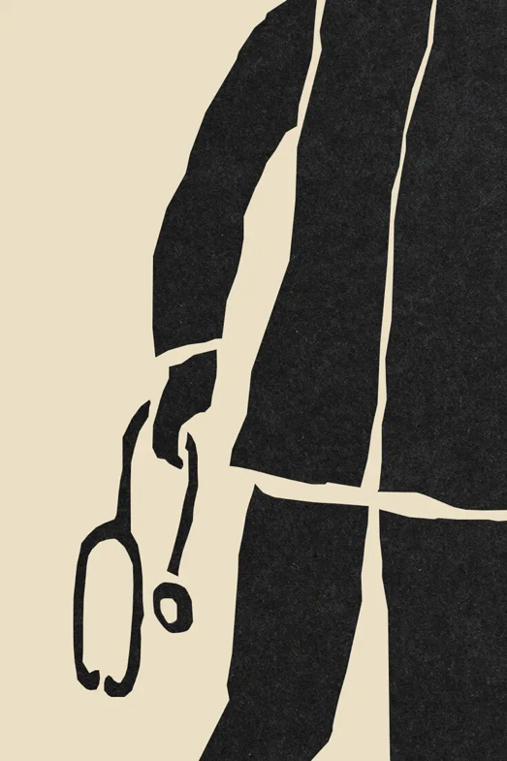
Content:
The image depicts the lower half of a figure, likely a person, dressed in a black coat or uniform, holding a stethoscope in their right hand. The figure is simplified and abstracted, showing only essential shapes and forms. The background is plain beige, which isolates the figure and emphasizes the subject. The stethoscope immediately signals a medical context, suggesting the figure is a healthcare professional.
Form:
The visual elements are stark and minimalistic, using a high-contrast black and beige palette. The composition emphasizes vertical lines and blocky shapes, creating a strong silhouette. The rough, uneven edges of the black forms resemble a papercut or linocut style, giving the image a textured, tactile quality despite its simplicity. The negative space, the beige background, is crucial, shaping the form of the figure and making the stethoscope stand out clearly. There is no shading or color variation; the focus is purely on shape and outline.
Meaning:
The image conveys a sense of authority, responsibility, and perhaps somberness. By reducing the figure to abstract shapes, it creates a universal representation of a medical professional rather than an individualized portrait. The stethoscope is both a literal tool and a symbol of care, expertise, and health responsibility. The overall mood is serious, reflective, and professional, possibly hinting at weighty medical or ethical issues.
Conceptual techniques:
The stethoscope and the partial figure represent the whole concept of healthcare professionals or the medical system. The abstraction inverts typical expectations of a medical portrait, focusing on minimalism rather than detail. The partial depiction of the figure isolates the hand and stethoscope, emphasizing their importance and drawing attention to the act of caregiving or intervention. The stark black figure against the pale background could symbolize the gravity or the burden of medical responsibility, possibly hinting at systemic or ethical dilemmas.
Personal reflection:
This image strikes me with its simplicity yet weighty resonance. I feel a mix of admiration and contemplation; it’s not just a picture of a doctor, but a visual meditation on responsibility and care. The abstraction forces me to focus on the symbolic rather than the literal, making me reflect on the human weight behind medical decisions and interventions. I also find the rough textures compelling; they make the image feel grounded and human, despite the minimalism. It leaves me thinking about the quiet, often unseen labor of healthcare professionals and the trust society places in them.
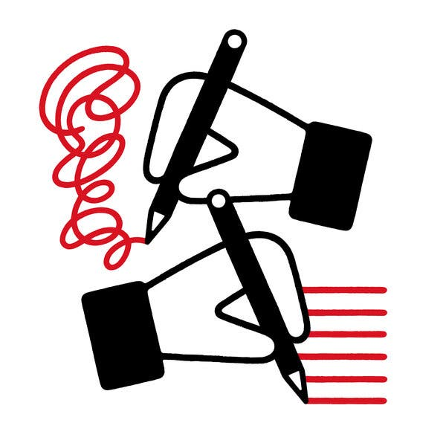
Content:
The image depicts two stylized hands, each holding a pen. The upper hand draws a tangled, looping red line that spirals chaotically, while the lower hand draws straight, orderly red lines. Both hands are simplified and geometric, rendered in black and white, emphasizing contrast and clarity.
Form:
The visual style is minimalist and graphic, using strong lines, bold shapes, and a limited color palette of black, white, and red. The composition is vertically balanced, with the chaotic scribble at the top and the structured lines at the bottom, creating a visual contrast between disorder and organization. The smooth, clean forms and lack of shading or texture give the image a flat, modern aesthetic. The red lines stand out sharply against the monochrome hands, directing the viewer’s focus to the act of drawing the contrast between the two outcomes.
Meaning:
The image conveys a message about the transformation of chaos into order, or the dual nature of creativity and control. The upper scribble symbolizes confusion, unfiltered expression, or the raw beginnings of an idea, while the lower straight lines represent clarity, structure, and refinement. Together, they illustrate the process of thinking, writing, or creating, moving from messy brainstorming to organized execution. The contrast suggests that both chaos and order are essential parts of the creative process.
Elements of Conceptualization:
The act of writing is used as a metaphor for thought or expression, from disorganized ideas to coherent communication. The pairing of two contrasting actions (scribbling and line-making) highlights the tension between creativity and control. The hands and pens symbolize the human mind and its ability to create, refine, and make sense of complexity. What might typically be seen as “mistakes” or “messiness” in the upper hand is reinterpreted as a necessary stage leading to the precision below. The image implies that order can emerge from disorder, a contradiction that reflects the nature of thinking and creativity.
Personal Reflection:
This image resonates deeply with me because it captures the internal struggle I often experience when trying to bring clarity to complex ideas. The chaotic red loops remind me of how my thoughts initially feel, tangled and overwhelming, while the straight lines below represent the satisfaction of finally expressing those ideas clearly. It evokes the creative process itself: the frustration of confusion and the relief of organization. I see it as a visual metaphor for learning, writing, or even emotional growth, a reminder that clarity doesn’t exist without first embracing the mess. It speaks to the beauty of progress, not perfection, and to the idea that disorder is not failure but a necessary step toward understanding.

